DeVry University – EET 202L (*Laboratory Report Cover Sheet)

Experiment / Assignment #1
Investigation of Latches and Gated Latches

Name(s) | Professor: Ron Surprenant

*Summary (two sentences):

________________________________________________________________________
*Report Checklist (Include the following sections in your report):
1. Introduction & Background |  | 4. Results: Data, Tables, & Diagrams
2. Procedure |  | 5. Analysis of Results
3. Troubleshooting & Testing |  | 6. Conclusions
*Key Results:

________________________________________________________________________
Deliverables: All sections that contain a deliverable are identified with an *.
- This Lab. Report Cover Sheet with Summary & Key Results responses.
- Section A-15: Copy of combsch\latches.rpt file.
- Section B-18: Copy of combsch\latches.scf file.
- Section B-19: Truth Tables.
- Section D-5: Scope time measurements & Instructor’s Sign-off
- III. Questions.
- Lab Report

Date Due: | Date Submitted:
Student(s) Signature:

I. OBJECTIVES
- To simulate the operation of a basic 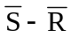 NAND latch.
- To simulate the operation of the gated S-R and gated D latches.
- To build a NAND latch and compare the operation with predicted behavior.
- To build a gated D-latch and compare the operation with predicted behavior.

II. PARTS LIST

Equipment:
IBM PC or Compatible with Windows 2000 or Higher
MAX+PLUS II Design Software - Version 10.1
Floppy disk or ZIP disk
Agilent E3631A Triple Output DC Power Supply
Hewlett Packard HP54600B Oscilloscope
Hewlett Packard HP33120A 15MHz Function Generator
Parts:
1 – 74LS00 quad NAND gate 1 – Red LED
1 – 74LS04 hex Inverter 1 – Green LED
2 – 1.0 kΩ resistor, ¼ W, 5% 2 – 330 Ω resistors, ¼ W, 5%
1 – SPDT Switch, DIP configuration

INTRODUCTION
Latches provide the basis of sequential logic by giving a mechanism for storage of digital signals. In sequential logic the outputs depend on both the inputs and the previous condition of the inputs and/or the outputs of the circuit. This differs from combinatorial logic, where the outputs are determined solely by the current states of the inputs.
A basic latch can be constructed with two NAND or two NOR gates using feedback to lock onto and hold the data. Simple modifications of this circuit can create a gated latch, which allows for control of when the latch is activated. A further modification can create a circuit that eliminates any illegal states.

PROCEDURE

A. Graphic Entry of Latches
- Open the MAX+PLUS II Main Window.
- Select FILE|NEW to open a Dialog Box. In the New Dialog Box click on Graphic Editor File (gdf) to open the schematic page window.
- Select FILE|SAVE AS to open up the Save Dialog Box and then select the drive for a floppy or ZIP disk. In the filename box, enter (drive):\combsch\latches.gdf to save this file.

- Select FILE|PROJECT|SET PROJECT TO CURRENT FILE. This will set the top banner to the current file and it should have (drive):\combsch\latches.gdf in it.

- Enter the circuits shown in Figure 1.1 onto the schematic page. Do this by Right clicking on schematic; Enter Symbol: Choose Drive:\\ maxplus2 \ max2lib\prim (Library); scroll down to NAND2 & select.
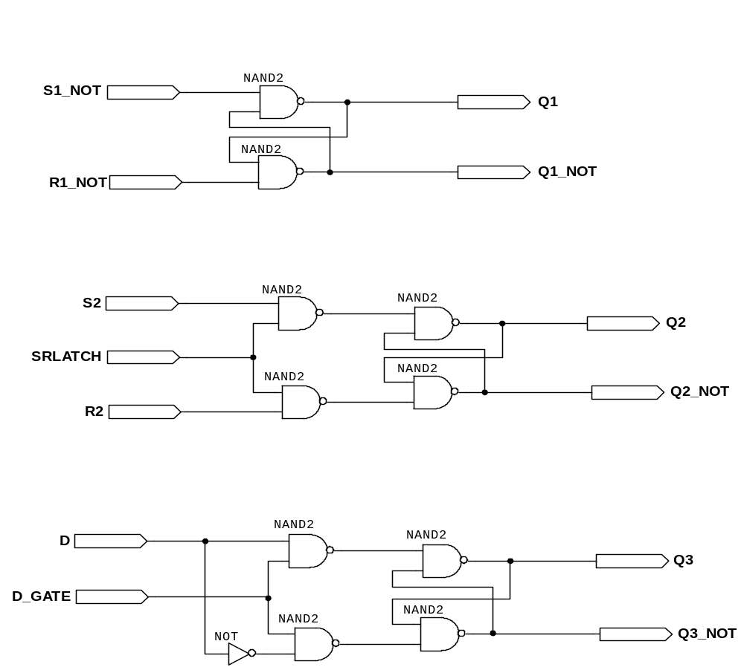

Figure 1.1 – Latches and Gated Latches

- Select FILE|PROJECT|SAVE and CHECK. This opens the compiler window and runs the first process step of the compile.

- Perform the following to check errors, specify the device used and generate a basic design report. The upper toolbar, shown in Figure 1.2, can be used in some steps.

COMPILER SIMULATOR
Figure 1.2 - MAX+PLUS II Tool Bar
- Select PROCESSING and ensure that the Smart Recompile is enabled (indicated by a check mark).

- Select ASSIGN|DEVICE and set Family = MAX7000S, and Device = EPM7128SLC84-15, then “OK”.

- Select ASSIGN|GLOBAL PROJECT DEVICE OPTIONS and set JTAG Support = ON, and “OK”.

- Select ASSIGN|GLOBAL PROJECT LOGIC SYNTHESIS and set Style = NORMAL and “OK”.

- Select PROCESSING|REPORT FILE SETTINGS, select ALL and “OK”.

- Click on the START Button on the compiler to start the compile process. If the process hangs up, click on the STOP button.

- The compiler should complete all of the process blocks and generate the following files: Compiler Netlist Extractor = .cnf, Fitter = .rpt, Timing Extractor = .snf, and Assembler = .pof.

- *Double click on the .rpt file to open the design text file. Check this to find the pin-outs of the design, logic equations and actual usage of the chip resources. Select FILE|PRINT to obtain a hardcopy of the report file to be turned in with your report.

B. Simulation of Latches
- Select FILE|NEW and Waveform Editor (.scf) to open a waveform edit window.

- Select FILE|SAVE AS and repeat the steps given in Step 3 of the previous section to save this file as (drive):\combsch\latches.scf.
- Use FILE|PROJECT|SET PROJECT TO CURRENT FILE.
- Select FILE|END TIME and set the end time to 1.0μS (the default value).

- Select OPTIONS|GRID SIZE and set to 100nS.

- Select NODE|ENTER NODES FROM SNF. In the dialog box ensure the “Inputs and Outputs” box is checked and press LIST.

- Highlight all of the signals (use the mouse to drag and highlight). Press the “=>” to transfer the highlighted nodes to the select list.

- Be sure they are all there and click on “OK”.

- This places all the nodes in the SCF Simulator window with a default value of 0 for the inputs and XXXX for the outputs.

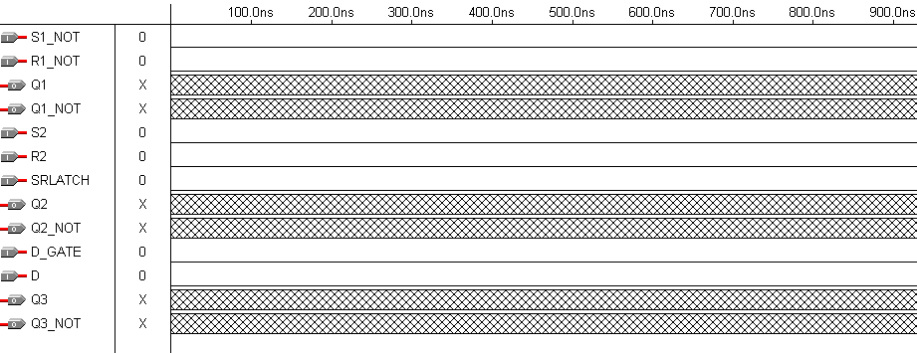
- Rearrange the signals so that they appear as shown in Figure 1.3. The signals can be moved by clicking their 3-D arrow then dragging and dropping with the mouse .

Figure 1.3 – Initial Timing Diagram
- Select OPTIONS and disable the SNAP TO GRID (remove the check). This will allow entry of clock signals.

- Select S1_NOT and in the simulation toolbar select the Overwrite with Clock icon (a pulse with a clock in it). Set the Start Value = 0 and Period = 100nS and “OK”.

- Select R1_NOT and set a clock to Start Value = 0 and Period = 200nS.

- Repeat Step 12 for Inputs S2 and D_GATE. For S2, use Start Value = 1.

- Repeat Step 13 for Inputs R2 and D_GATE. For R2, use Start Value = 1.

- Select SRLATCH and set a clock to Start Value = 1 and Period = 400nS.

- Select the Simulator the Tool Bar (shown in Figure 1.2) and press START to run the simulator. Open the SCF File to view results on Q1, Q1_NOT, Q2, Q2_NOT, Q3 AND Q3_NOT. They should no longer show XXXX signals.

- *Select FILE|PRINT to print out a hardcopy. Turn this in with your report.

*Using the simulation results from Step 17, complete the truth tables for the three types of latches tested.
S1_NOT | R1_NOT | Q1 | Q1_NOT
0 | 0
0 | 1
1 | 0
1 | 1

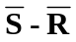 Latch Truth Table

S2 | R2 | SRLATCH | Q2 | Q2_NOT
0 | 0 | 0
0 | 1 | 0
1 | 0 | 0
1 | 1 | 0
0 | 0 | 1
0 | 1 | 1
1 | 0 | 1
1 | 1 | 1

S-R Gated Latch Truth Table

D | D_GATE | Q3 | Q3_NOT
0 | 0
1 | 0
0 | 1
1 | 1

D Latch Truth Table

C. Build and Test the Latch
- Build the latch shown in Figure 1.4. The LEDs are wired as active-LOW since the gates can supply more current in a low state than in a high state. This means the green LED is illuminated when 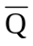 is HIGH and the red LED lights when Q is HIGH. NOTE: Make sure to connect Pin 7 to Ground & Pin 14 to +5V.
- Using the circuit, verify that the operation follows the truth table from the simulation.

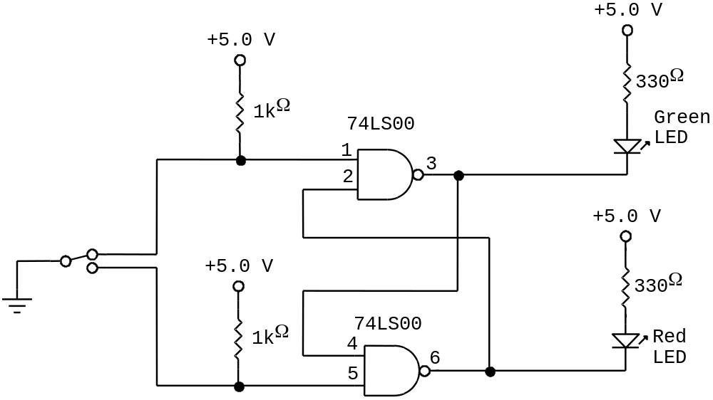
Q
!Q

Figure 1.4 - Latch

D. Build and Test the Gated D Latch
- 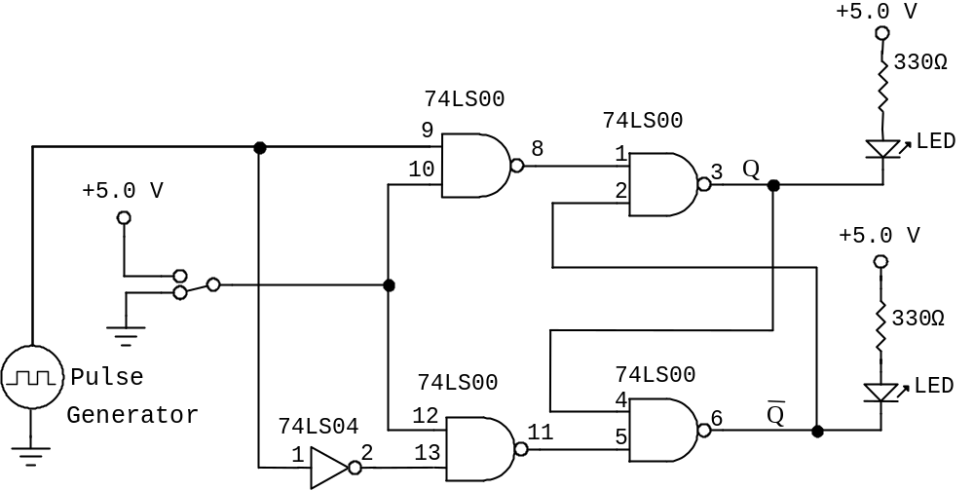Modify the latch circuit into the gated D latch circuit shown in Figure 1.5.
+ = ENABLE

- = DISABLE
Figure 1.5 – Gated D Latch
- Set the pulse generator to produce a 1 Hz TTL output and observe the LED results with the enable input set to HIGH and then to LOW.
- Remove the LEDs and connect the Q and outputs to both channels of a dual-trace oscilloscope (also remove the resistors and +5 volt connections).
- Set the enable line to +5 volts and set the pulse generator to produce a 1 MHz output.
- *Using the oscilloscope, measure the high-to-low (t_{PHL}) and low-to-high (t_{PLH}) propagation delays between the input (pin 9) and the output (pin 3). Synchronize the scope to Pin 3. Record the values below and have your instructor sign-off on your measurement.
t_{PHL} = ______________________ t_{PLH} = __________________________
Instructors Sign-off _____________________

*QUESTIONS
- Why is the state when S1_NOT and R1_NOT both are LOW in a considered illegal?
Since the two inputs S1 and R1 are inverted, their corresponding inputs can be considered to be a 1 and a 1 as in a normal NOR latch, in which its’ illegal state is an active HIGH. This illegal state (1 , 1 in an active high, while 0 , 0 ) in an active LOW gate) causes both outputs to attempt an action at the same time. Since these outputs are attempting to do inversely related actions, such a thing cannot occur.

- Does the S-R gated latch have any illegal states? If so, what are the conditions that produce this?
Yes, the S-R gated latch contains an illegal state when all of its’ inputs are high.

- Does the gated D latch have any illegal states? If so, what are the conditions that produce this?
No the gated D latch has no illegal states since it has only two inputs. The first input D corresponds with data while the second input functions as an ENGAGE signal, effectively halting all operation when it is not present.

- In the simulated output of the gated D latch, the Q3 and Q3_NOT outputs are shown as XXXX for the first 50 ns. Why do these outputs not have a defined value?
This is due to the fact that during the first 50 ns of our simulated circuits operation there are no signals being sent through the gated latch. This means that according to our simulation, it has no values. I imagine however that in a real circuit this would not be the case.

- What advantage does the gated D latch have compared to the gate S-R latch?
The gated D latch has the distinct advantage that it does not require two inputs. While its circuitry is a little more complex, this complexity can save its’ creator from the possible nightmare of tracing a lost signal through countless timing diagrams. The D gate also has the advantage of having no INVALID state.

LAB REPORT

1.) Introduction and Background

Many real world applications require some form of interface with electronic devices. One such way for an analog behavior to be sampled into a digital form is to use a switch. One such example of a device like this is to imagine a pharmaceutical manufacturing plant. Within this plant there is a machine that counts pills falling into a pill container. If there were to be a switch in the way of these pills that registered each pill as it fell into the bottle, then you would have a discrete representation of how many pills are going into the bottle. Furthermore, after a set number of pills fall into the bottle, the machine can then close a release valve and move to the next bottle.

2) Procedure

Our basic procedure is as follows (however for a more complete description if please see above lab):
- Used Basic hardware and “bread boarded” a fully operational S! R! latch
- Used Basic hardware and “bread boarded” a Gated D Latch
- Used MAX PLUS graphical design environment to fully implement the following:
  - S1_NOT and R1_NOT Latch
  - A NAND SRLATCH
  - A NAND D GATE with Enable

3.) Troubleshooting and Testing

Our main problem when doing this experiment was when we “bread boarded” our Gated D Latch. During the gates operation we were getting the green light to flash (Q OUTPUT) while the red LED was staying off. In order to solve this problem I performed the following steps:
- Verified all connections from the power source and the clock (Function Generator)
- Verified that each component was properly wired as per schematic.
- Verified that the Power Supply and clock were at the correct settings.
- Verified that we were using the correct IC’s
- Took out all questionable wires and then rewired them.

Once we unplugged everything I noticed that we had a black wire with only about ¼ of an inch with exposed wire. I stripped the wire down a little more so that about ½ and inch was exposed and plugged it back in. I noticed then that the RED LED was not lighting up because of this wire. It was not connecting our LED to the Inverter gate, effectively rendering it to remain as the same signal D.

4.) Results: Data, Tables, and Diagrams

Most of our results were concluded from using the MAX + software and the tables provided in the lab. A copy of them is here as follows:

Latch Truth Table

S1_NOT | R1_NOT | Q1 | Q1_NOT
0 | 0 | INVALID | INVALID
0 | 1 | 1 | 0
1 | 0 | 0 | 1
1 | 1 | NO CHANGE | NO CHANGE

S-R Gated Latch Truth Table

S2 | R2 | SRLATCH | Q2 | Q2_NOT
0 | 0 | 0 | 1 | 0
0 | 1 | 0 | 1 | 0
1 | 0 | 0 | 1 | 0
1 | 1 | 0 | 1 | 0
0 | 0 | 1 | 1 | 0
0 | 1 | 1 | 1 | 0
1 | 0 | 1 | 0 | 1
1 | 1 | 1 | INVALID | INVALID

D Latch Truth Table

D | D_GATE | Q3 | Q3_NOT
0 | 0 | 1 | 0
1 | 0 | 0 | 1
0 | 1 | 0 | 1
1 | 1 | 1 | 0

5.) Analysis of Results

In our analysis of the results of this lab we have found that both the S! R! Latch and the SR Gated lab have invalid states. We also found that the SR gate has no NOCHANGE states and that the D Gate has no INVALID state.

6.) Conclusion

In conclusion we have noted that the D-Latch is the best latch. While it is more difficult to implement due to the fact that it requires many more gates, it is superior in that it has no “INVALID” states. This is a great feature, and for educational purposes we feel that it would be the best latch to use since it can’t go wrong.

SECTION D-5

